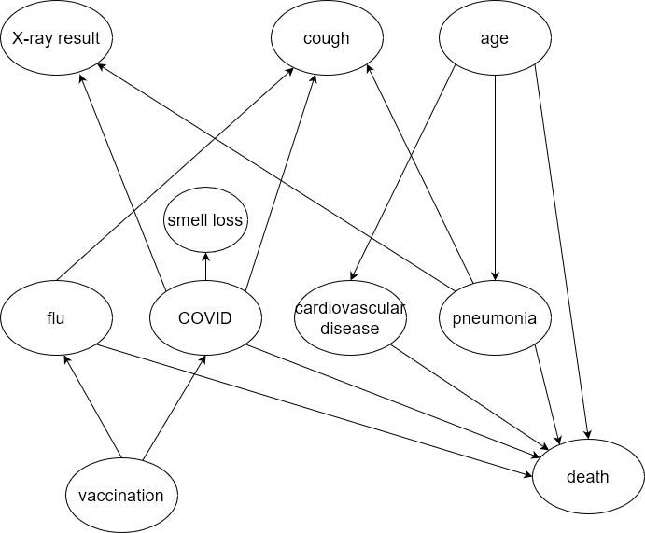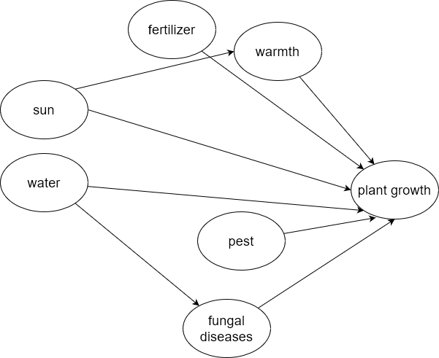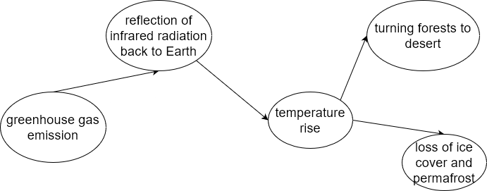

In case of respiratory illness diagnosis, the Bayesian approach could prove useful as there are many factors that can influence our belief about the diagnosis.

In the case of plant growth, the Bayesian approach is not that useful since the factors all influence a single outcome.

With the global warming, the process is pretty much linear and there is no need for a Bayesian approach.